Date/Day: Tuesday 11/20

TRADE: $QQQ 1 Put

Setups Traded: Pre-Market Short Scalp

Open Day P/L: $0

Closed Day P/L: -$27

Final Grade: C

Tech declined all of pre market. Based on pre market action & S/R, I was going to play a breakout to the short side on $QQQ, originally at $158.47. Opened below & went up so waited for a CLEAR BO below $157.89 (Good patience). Took a good risk/reward playing the breakout but with things being so volatile, I got stomped out quickly and had no interest in trying to re-enter in either direction. Tech was coming off a very strong day of selling. However, market was very choppy after open. Up & down, broke & came back several times. Should not take this trade setup unless direction/trend is clear. Move with caution next time and practice patience. For this setup, wait for clear direction like 11/19, it never looked back once it fell... CRUISE SHIP MOVEMENT!

I felt a little too eager to trade today, after missing big opportunities the day prior. Need to control emotions and not have any FOMO. Great traders wait for their trade, and conquer it. Don’t be fooled and pulled in by short term gain and emotions.

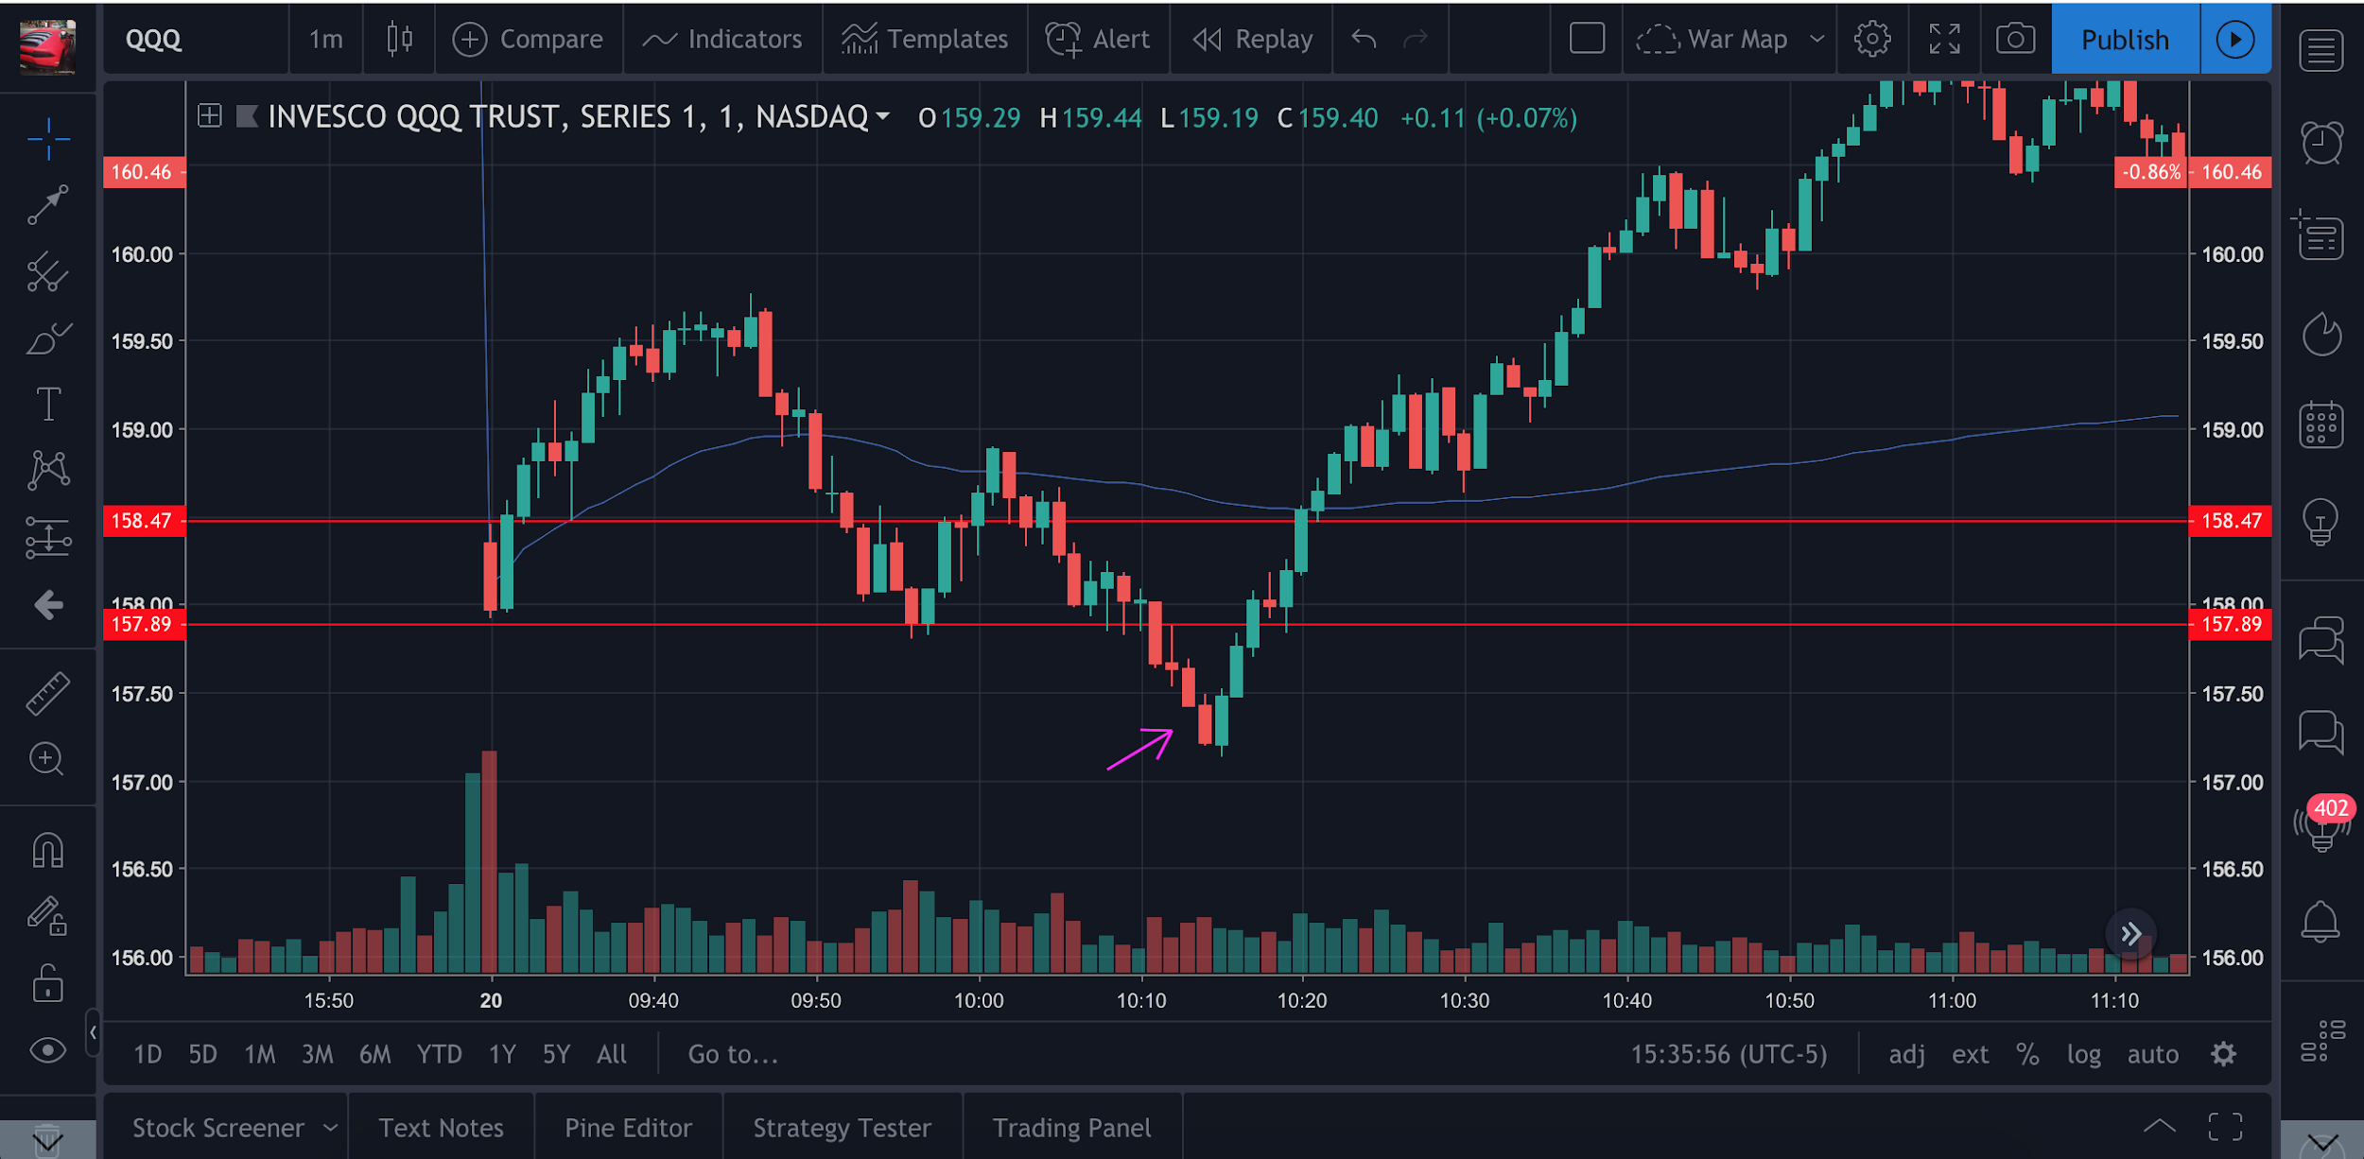
Date/Day:

Stocks Traded:

Setup Traded:

Open Day P/L:

Closed Day P/L:

Final Grade:

